**DishDash Project Documentation**

# 

Abelaash Giritharan (N01285813)

Jose Arango (N01510583)

Ming Lok Pun (N01510459)

Kirtan Parekh (N01477860)

Maitree Yadav (N01510854)

**TABLE OF CONTENTS**

Proposal…………………………………………………………………………………………………..3

Features of Application …………………………………………………………………………………4

Dish Dash Screen ………………………………………………………………………………4

Recipe Screen……………………………………………………………………….…………..5

Advanced Search Screen .……………………………………………………………………..6

Recipe Screen ...………………………………………………...………………………………7

Task distribution sheet ………………………………………………………...………………….……..8

# Proposal: DishDash App

DishDash can serve you a delicious serving of valuable time. DishDash is designed around convenience and efficiency. The app has a simple and straightforward functionality. The app can provide users with quick and easy recipe ideas with detailed information regarding the ingredients and the necessary steps in making the dish.

The app has a feature-rich homescreen which provides the users with 3 different choices. The user can choose to see any 10 random recipes or they could search for a specific recipe based on any ingredient. There is also additional functionality for the user to add any recipe to the favorites list. The user can then access the favorites screen by the click of a button to see all of the recipes which are added to the favorites list.

The app is designed for users from all backgrounds. Whether you are a mom searching for a new recipe to try out or you are a bodybuilder trying to find the perfect post-workout meal, we got you covered.

# Features Implemented

### Dish Dash Screen

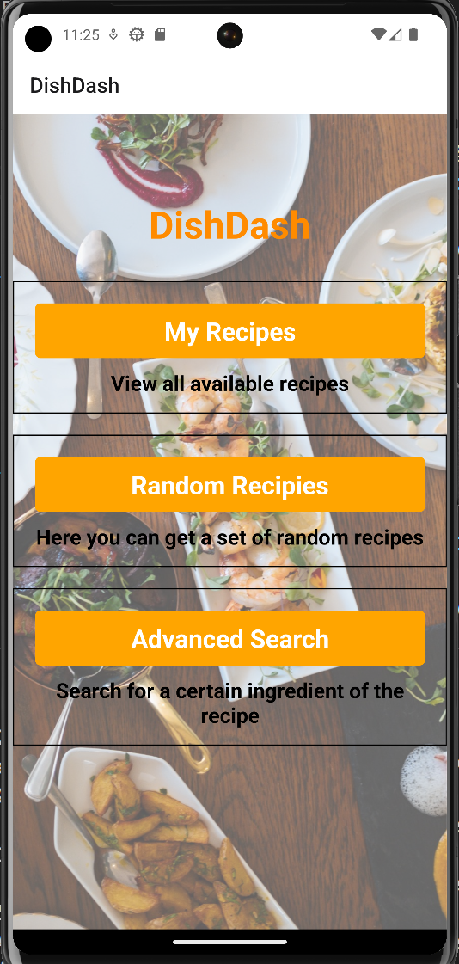

Here we can see the homescreen of the DishDash app. It has a title, followed by the 3 buttons which all lead to different screens and have different functionalities.

The title is colored to match the theme of the app, also it is animated to fade in whenever the app starts. The rest of the content on the page is mapped to a sequence() animation. Therefore, the text on the buttons and the description all fade in after the tile fades in.

The “My Recipes” button takes the user to the Favorites Screen, where they can see a list of all the favorite recipes. The “Random Recipes” button takes the user to the Recipe Screen, where they can see a list of 10 random recipes. The “Advanced Search” button takes the user to the Advanced Search Screen, where the user can search for any recipe based on any specific ingredient and they can also choose a type of cuisine from a drop down list.

### Recipe Screen

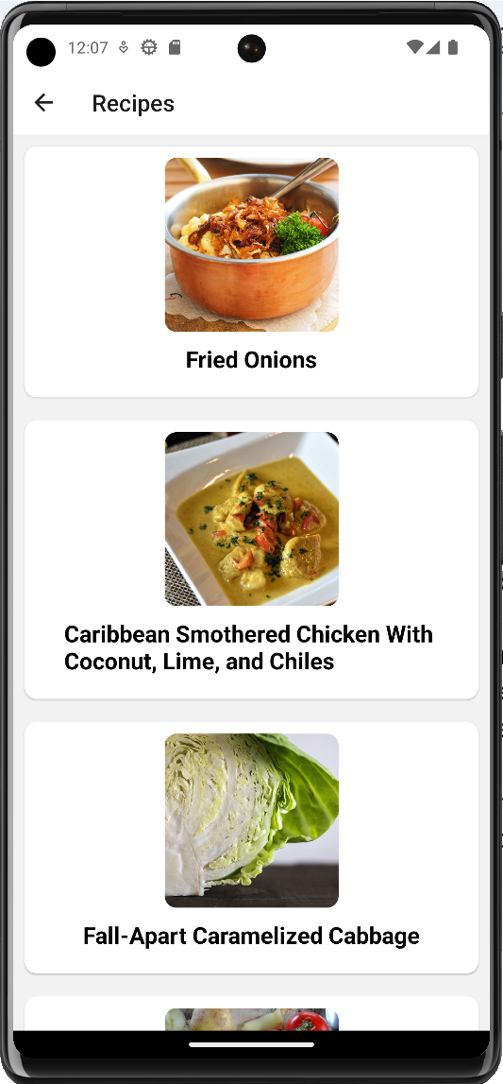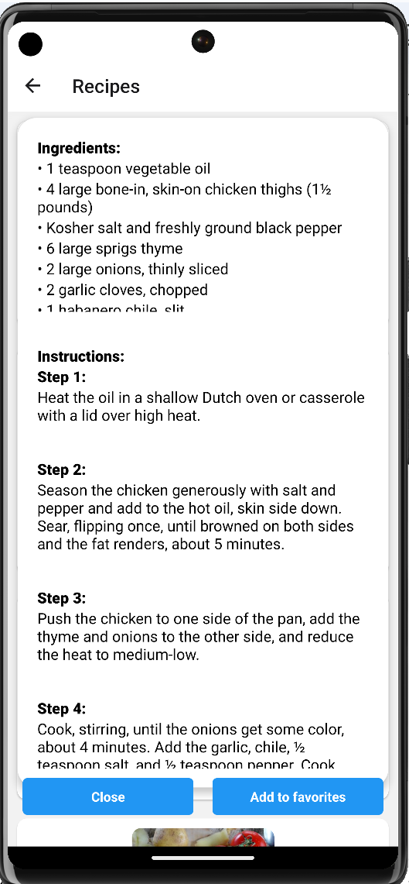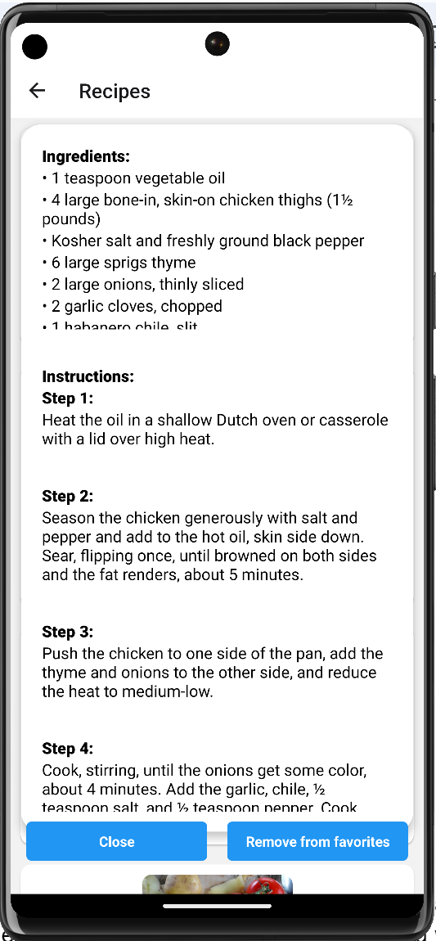

The recipe screen generates a list of 10 random recipes. It presents the user with a flatlist with all the recipes and each recipe is a touchable component. The recipes are displayed with the image. Upon clicking the recipe, the user will be shown a modal with all the details of that particular recipe.

In the modal the user is presented with a detailed scrollable list of the ingredients and a scrollable list of instructions. Each of these lists are fetched from the API. The modal also shows the user 2 buttons. One button to close the modal and go back to seeing the list of random recipes. The second button is to add the recipe to the favorites. Upon adding a recipe to the favorites, it shows the user an alert indicating that the recipe has been added to the favorites.

After adding the recipe to the favorites, the add to button changes its text and functionality and enables the user to remove from the favorites. Upon the removal also, the user is shown an alert indicating that the recipe has been removed from the favorites.

### Advanced Search Screen

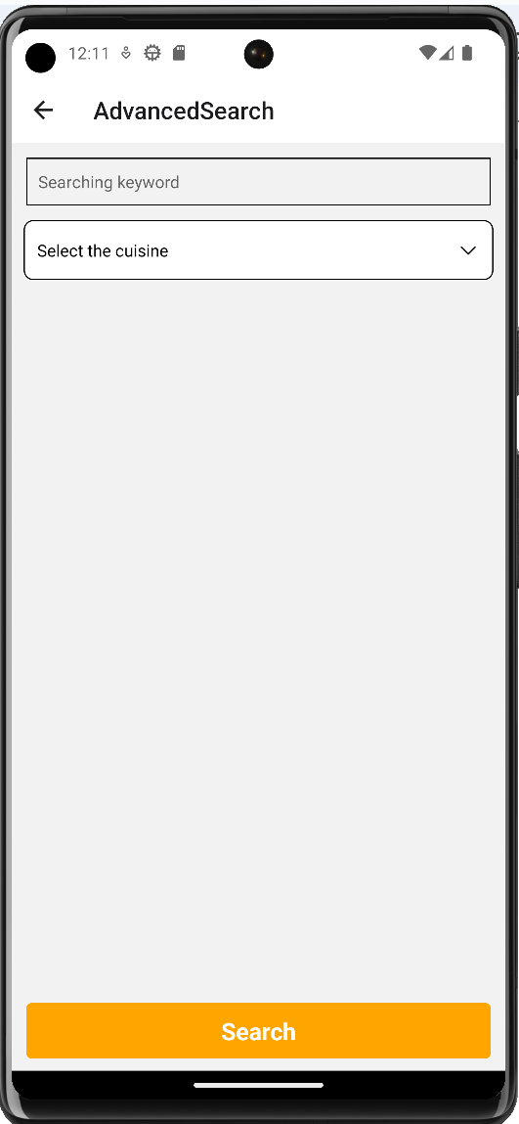 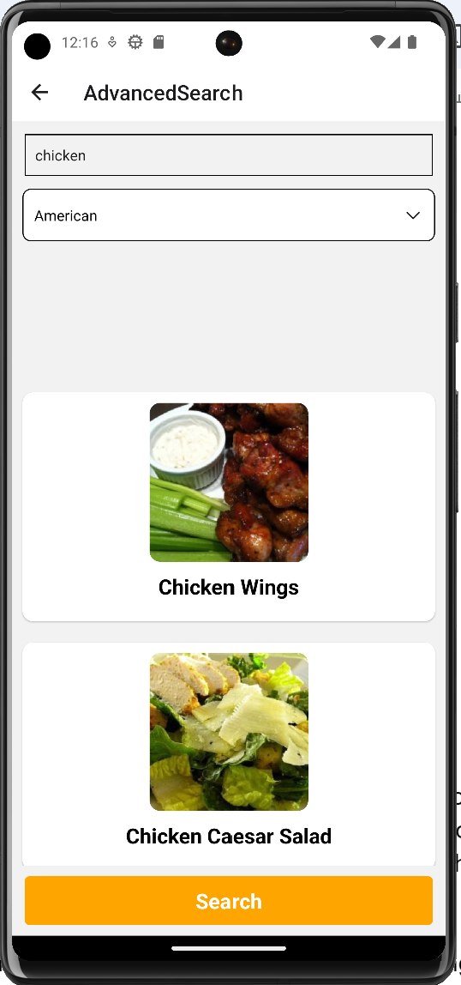

The advanced search screen allows the user to search for a recipe based on a keyword. It also gives the user the option to choose a cuisine from a drop down list. Once the user chooses the options based on their needs and click search, the app searches the api and shows the users all the recipes related to their search.

The recipes are displayed as a list and each of the recipes are clickable. Upon clicking the recipes it shows the modal with the list of ingredients and instructions.

### Recipe Screen

### 

The favorites screen shows the user a list of all the recipes which they added into the favorites list. Each item is clickable and it shows the modal with the ingredients and instructions. The modal has 2 buttons, one to close the modal and the other to remove the recipe from the favorites list. When the user removes the favorite, it shows an alert to the user.

# Task Distribution Sheet:

| **Student** | **Task** | **Status** |
| --- | --- | --- |
| **Abelaash Giritharan** | Modals, Progress, Navigation, Build | Completed |
| **Ming Lok Pun** | API, FlatList or SectionList, Modals, Project Config | Completed |
| **Jose Arango** | Redux store, Modals | Completed |
| **Maitree Yadav** | FlexBox | Completed |
| **Kirtan Parekh** | Touchable Components, Animations, Documentation | Completed |